2. feladatlap
What do you know about Halloween?
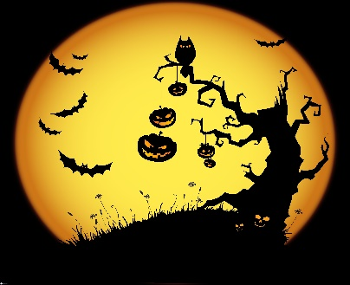
2. Read the text and complete the gaps
PUMPKINS TRADITIONS YEARS HALLOWEEN
OCTOBER FOOD PEOPLE COUNTRIES

Where does Halloween come from?
We celebrate Halloween every year on _1._____________ 31st. But where does this holiday come from?
The holiday originally comes from a people called the Celts. The Celts lived in Europe more than 2000 ___2.____ ago. On November 1st they celebrated the end of summer. They thought ghosts visited the living on October 31st. They dressed up like ghosts so the spirits would not harm them.
Today, many __3.____________ still remember the dead on November 1st. It is called All Saints day. Another name for it is All Hallow’s Day. The day before, October 31st, is called All Hallow’s Eve, or _4.________________ for short.
Halloween is an old tradition in Ireland and Scotland. In those countries, ___5.__________ dressed up and carried lanterns made of turnips. When people moved from Ireland and Scotland to the United States, they started using ___6._____________. This is where the jack-o’-lantern comes from.
They also had a tradition of giving ____7.______ to the spirits. Later, they gave the food to poor people. This is where trick-or-treating comes from.
Halloween has changed a lot since its origins. New people have brought new _____8.____________, and changed the old ones. What do you think Halloween would be like in another two thousand years?

3. Read the text again and answer:
- What is this story about?
- Trick-or –treating
- Ghosts
- The origins of Halloween

- When did the Celts live in Europe?
- More than two hundred years ago
- More than two thousand years ago
- Less than two thousand years ago

- What did they celebrate on November 1st?
- Halloween
- All Hallow’s Day
- The end of summer

- What did ghosts do on October 31st?
- They visited the living
- They dressed up
- They celebrated All Hallow’s day

- The word Halloween comes from …
- All Hallow’s Day
- All Saints Day
- All Hallow’s Eve

- Nowadays, jack-o’-lanterns are made of…
- Turnips
- Pumpkins
- Carrots

- Trick-or-treating comes from…
- Giving money to the poor
- Giving food to the spirits
- Giving candies to children

